Bride Valley Gardening Club

Welcomes you all to our 2026
Celebrity Speaker

David Hurrion

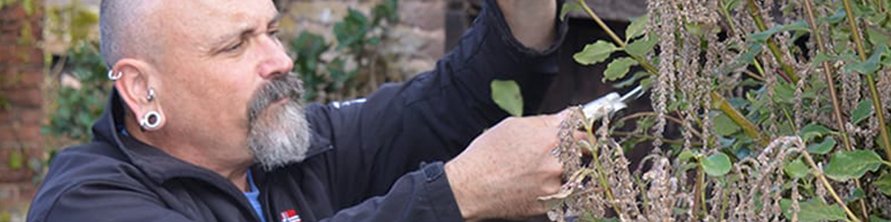

“Creating a Jungle Garden”

David is a Gardening Journalist, Tutor, Lecturer and
RHS Judge as well as
Associate Editor for BBC Gardener’s World

Monday 15th June 2026
Litton and Thorners Community Hall, DT2 9AU
7 pm for 7.30 pm.

Tickets £5 in advance from Liz Gibbs
07751 942588
bridevalleygc@gmail.com

